Homework:

4. Complete R1:SP1:Story 1 – Find and document all of files that need to be loaded. Personally add at least 7 records to each source. The loan information is missing the Loan Date. To really get a good grasp of the data you are working with, I want you to add a Loan Date to all 3 sources so every record in your eventual loan table will have a Loan Date. Show screenshots of the data you personally loaded into the various files.

1. Excel file data created inside.

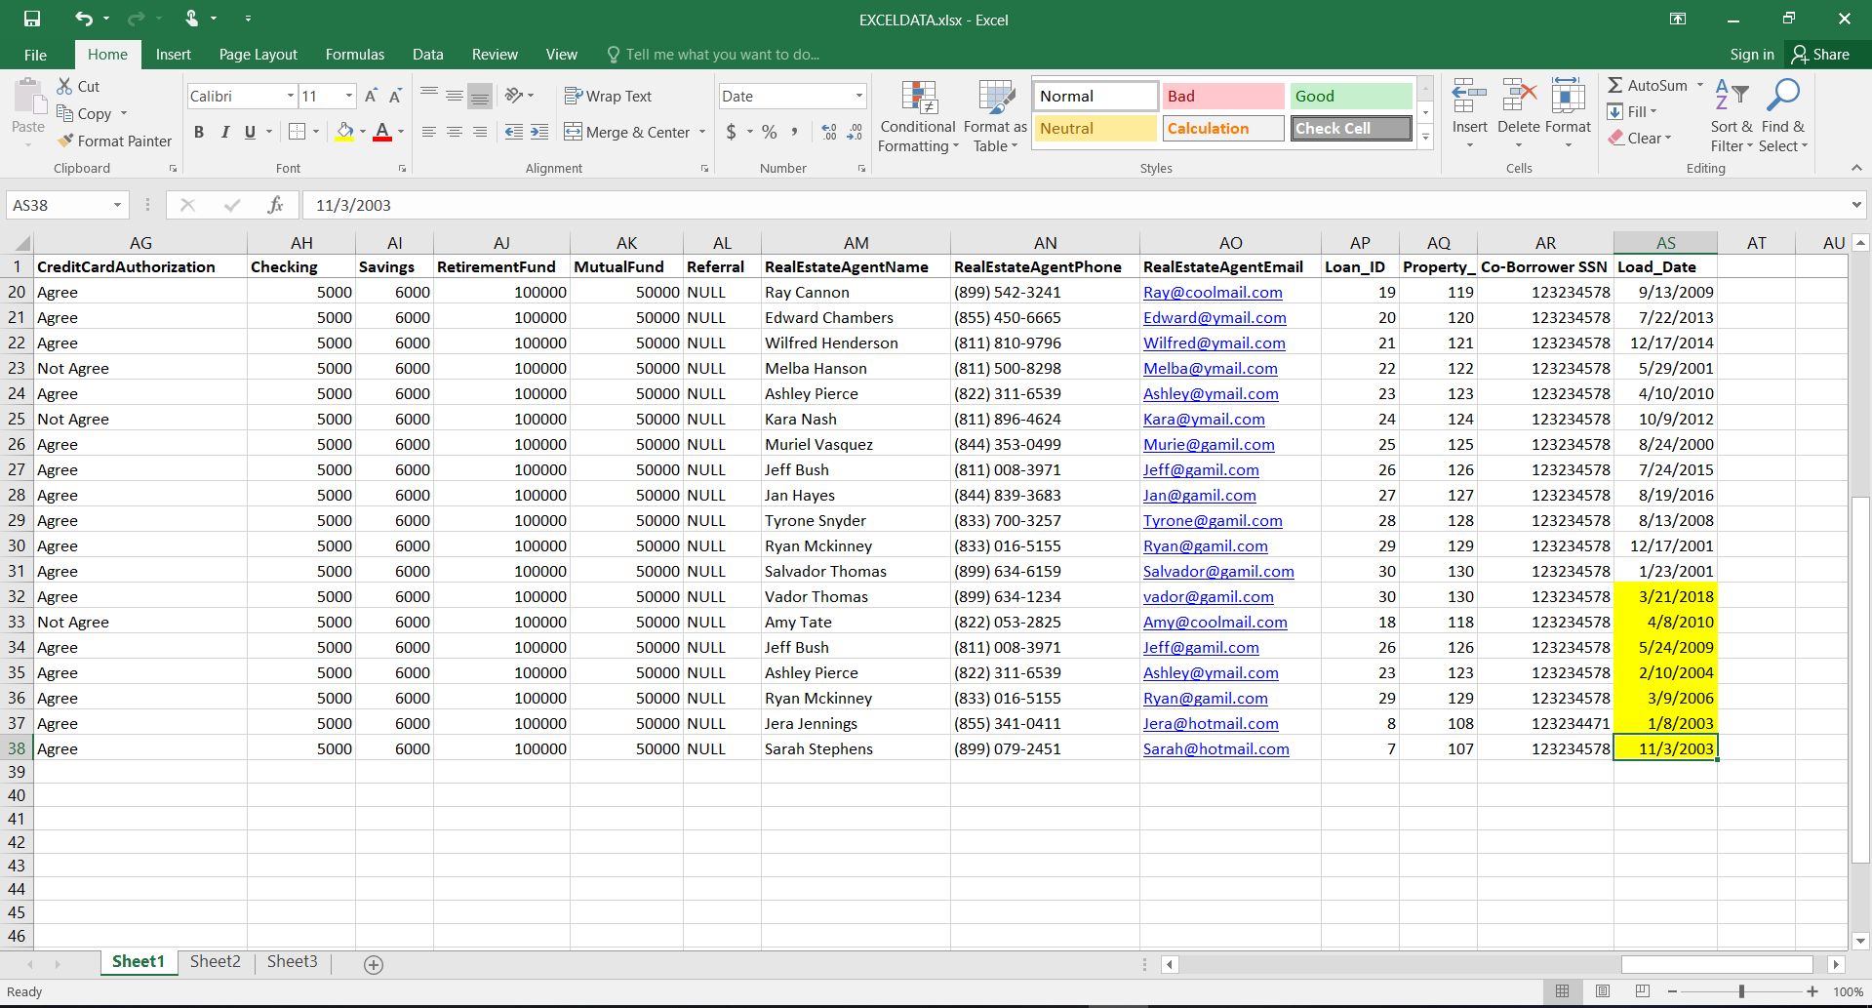

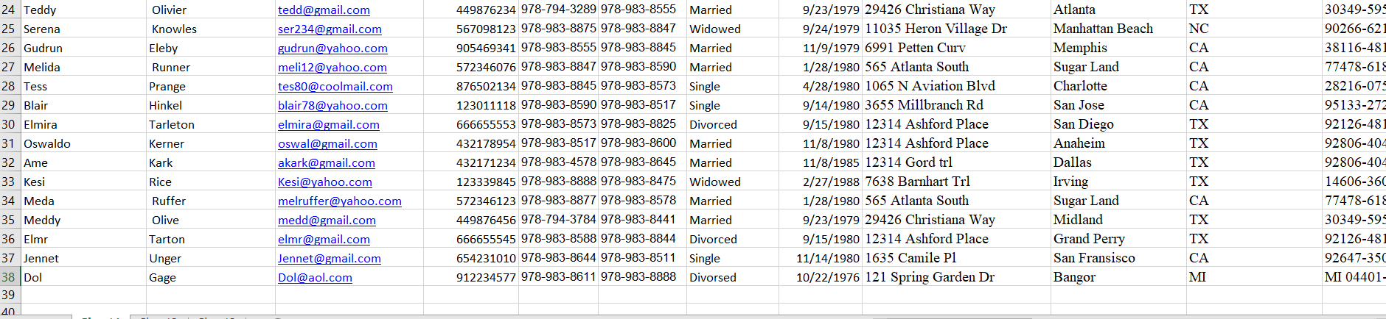

**2.. In database From SSIS package**

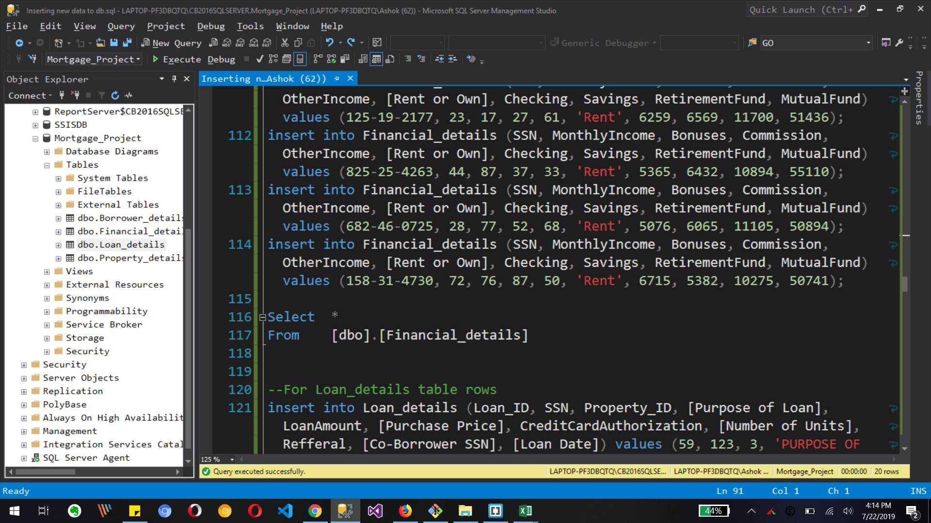

**Some data from Insert into table query**

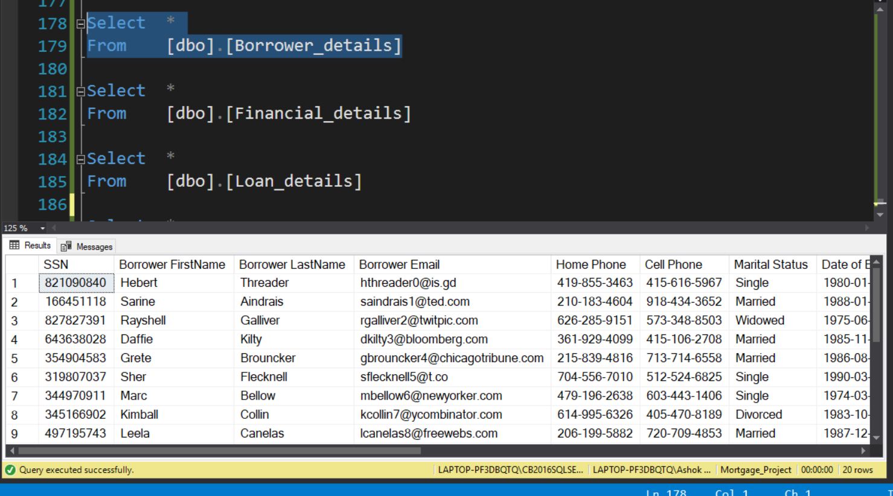

**Final 20 rows create by me for Borrower details table**

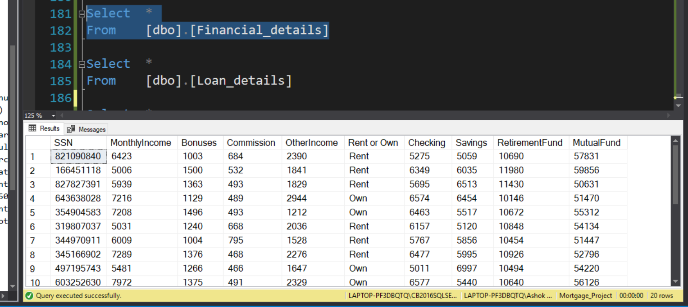

**Final 20 rows create by me for Financial details table**

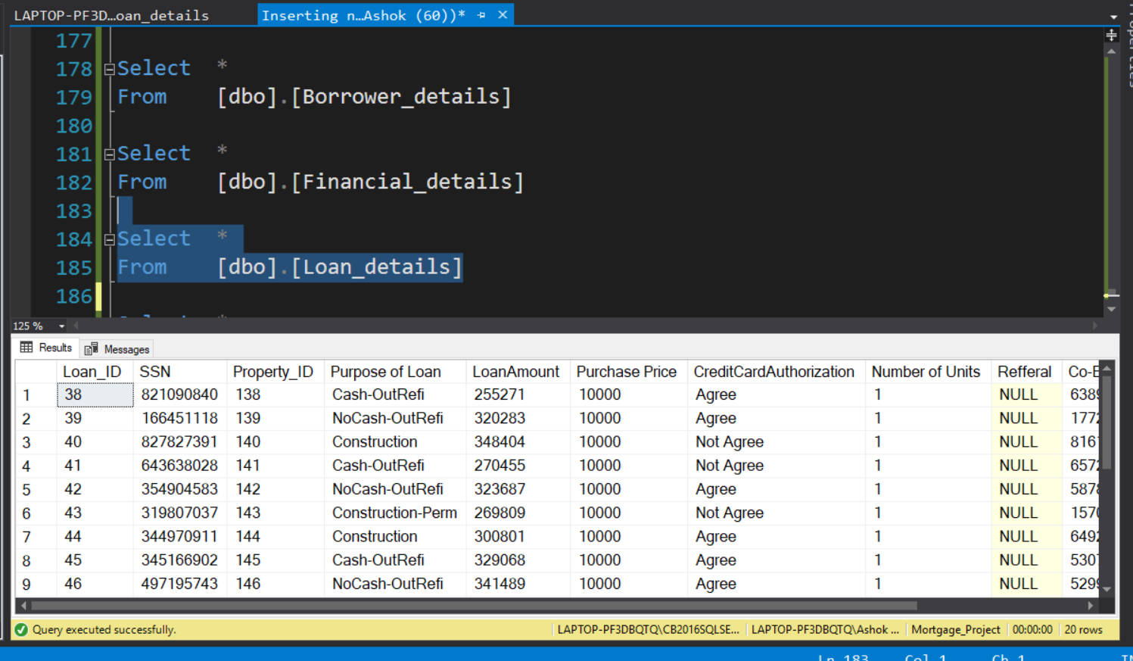

**Final 20 rows create by me for Loan details table**

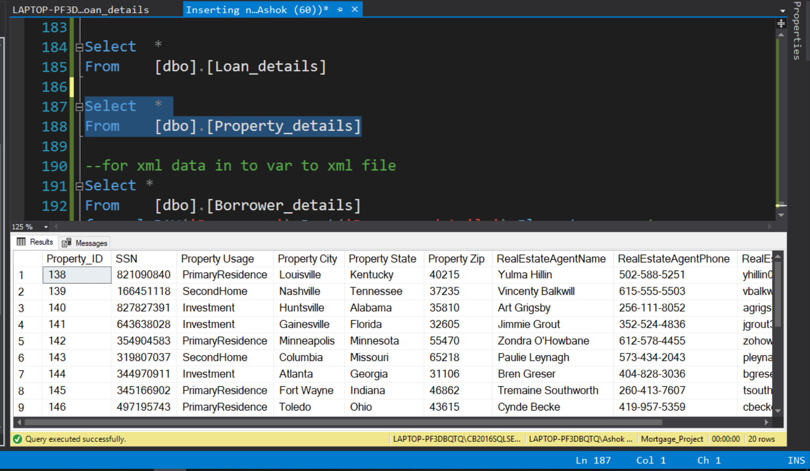

**Final 20 rows create by me for Property details table**

**3.. Creating xml file in SSIS for new data**

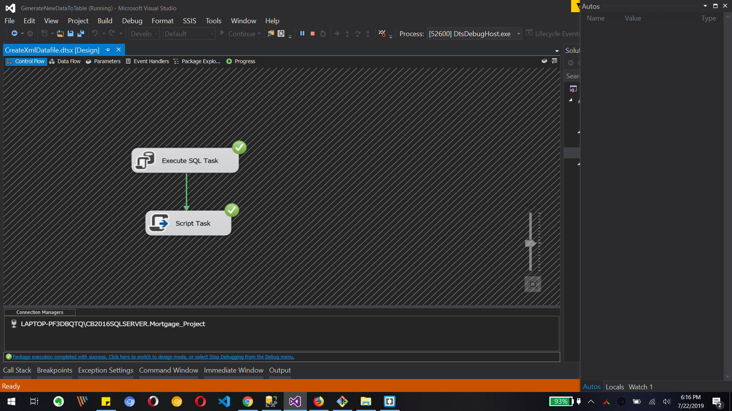

**Let’s create sql task and Script task to generate XML file from sql table.**

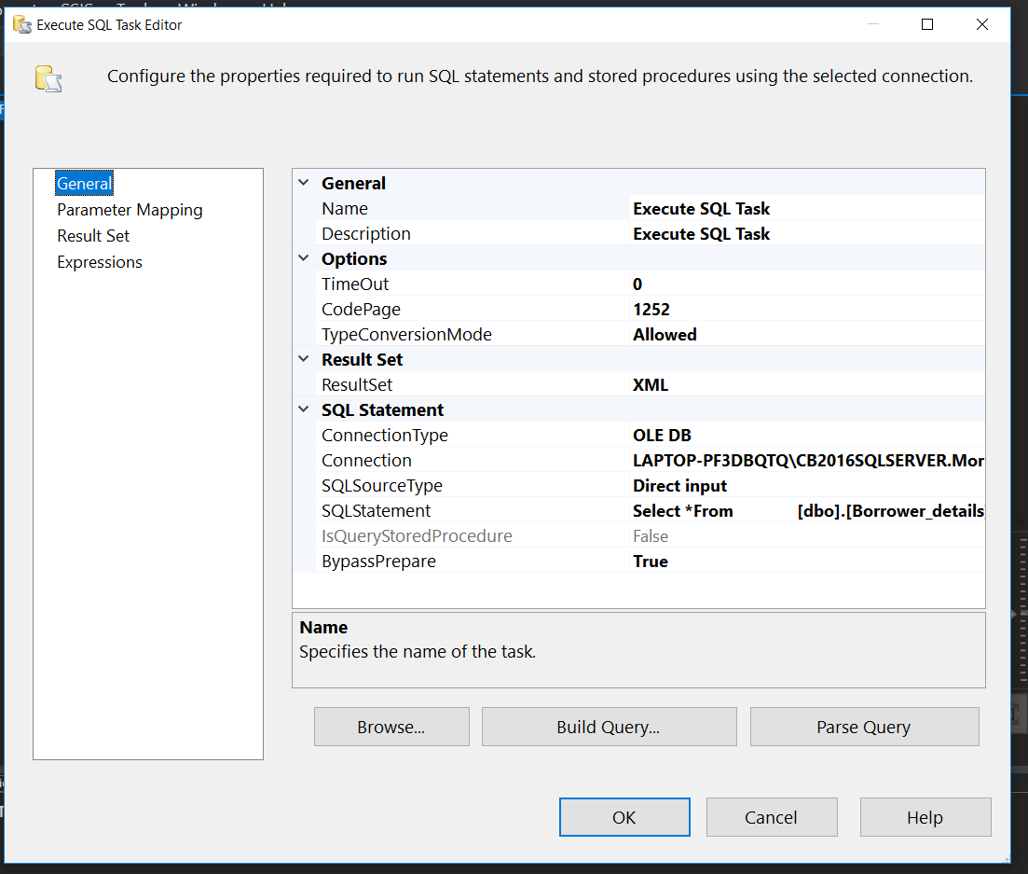

**The above image is for sql Task editor with xml result set and that is done with sql statement to generate xml data and we store that data into variable as xmldata in result set field.**

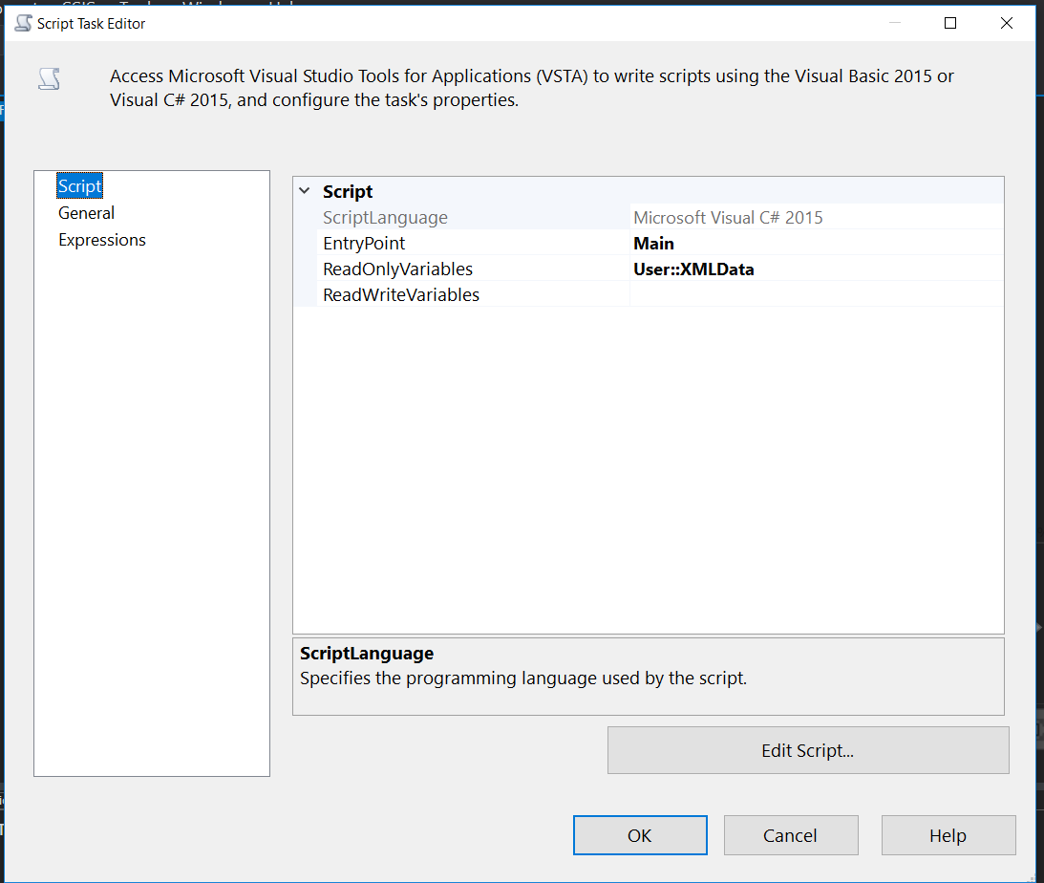

**Above image is script task editor to convert xml row data into string to store in xml file with C# code.**

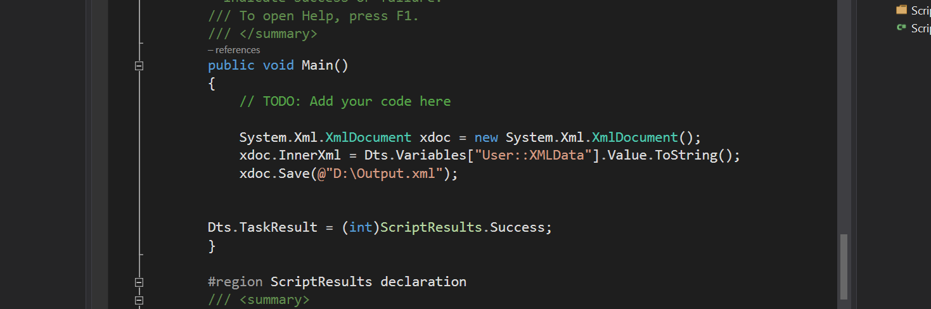

**Above is the C# code to convert stored data into xml file.**

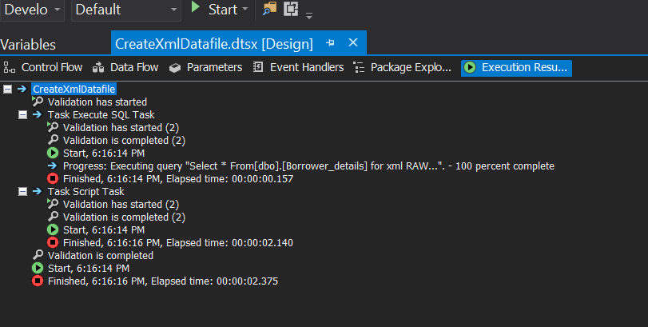

**The successful completion of tasks to create xml file with new 7+ rows in xml file**

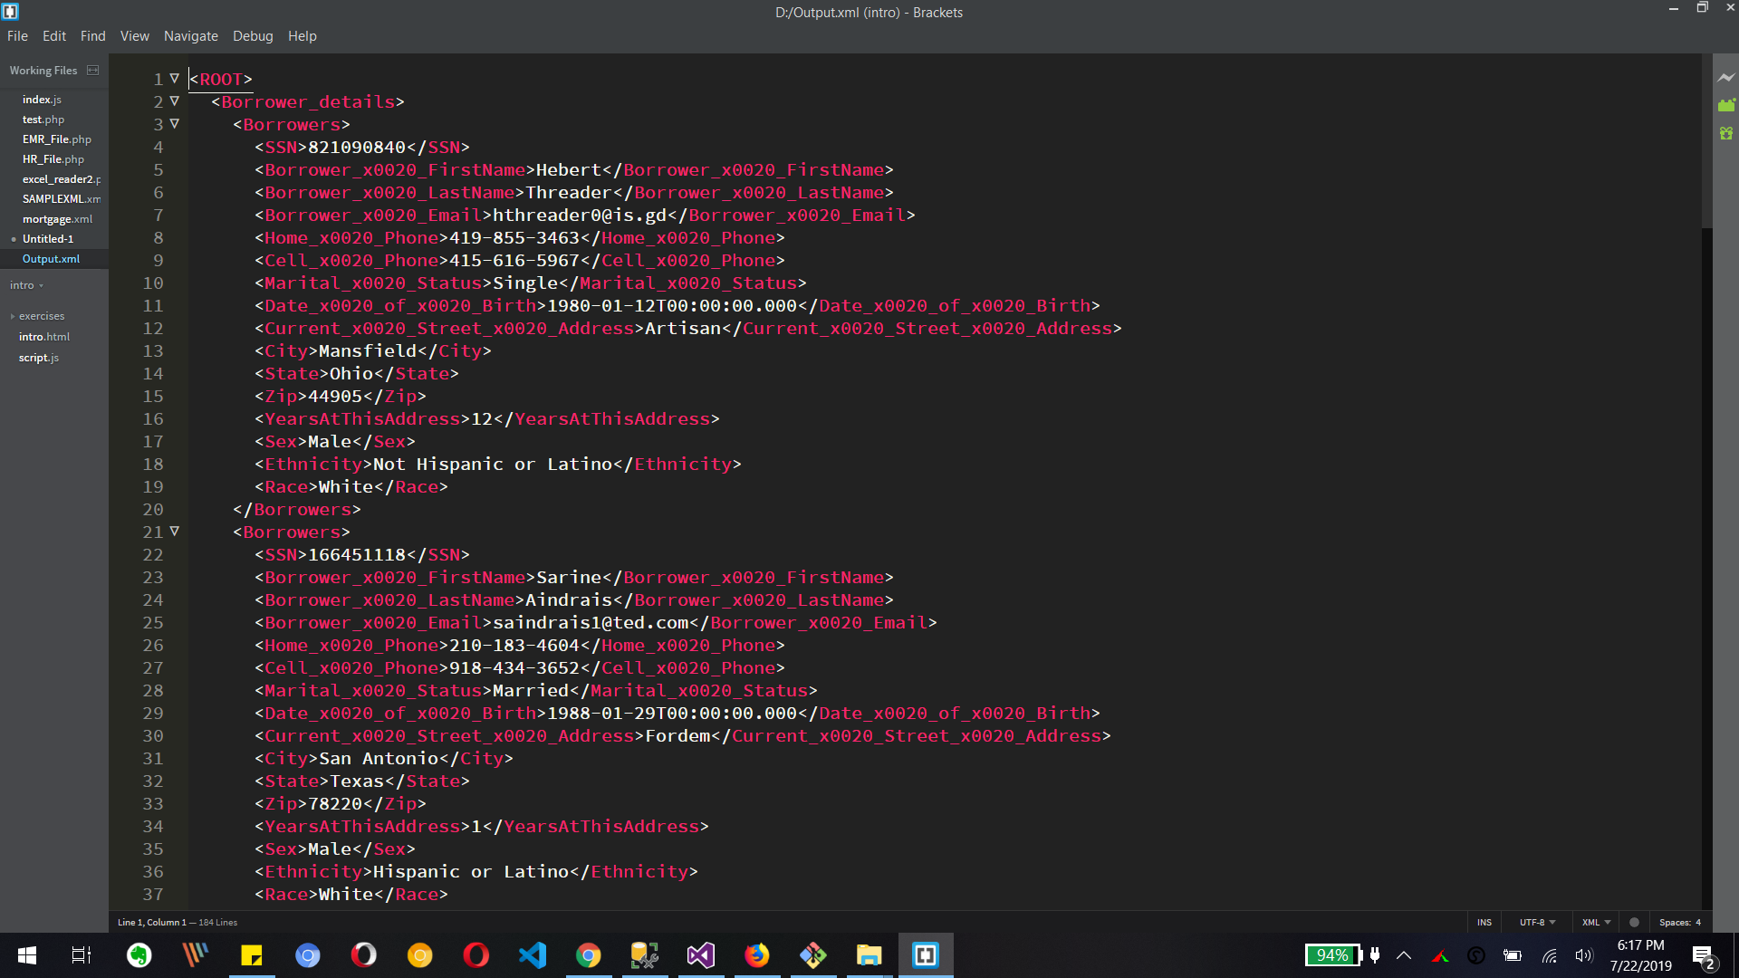

**Above is generated xml file open in editor to view.**

Video Submission:

To create a video, go to your IPBC Dashboard and half way down the page, you will find the Video section as shown below.

Video(s) to Submit:

1. SQL BI Interview Questions: SSIS – What are the various types of sources you have worked

with

2. SQL BI Interview Questions: SSIS – What is a data dictionary

What to Submit:

1. Copy and paste the link to your video(s) as part of your homework.

2. Watch, Comment &amp; take screenshots of your comments from 3 other videos on the same

topic (per question). Comments must be 20+ characters. Leave comments based on

presentation, delivery and/or technical details. Your critiques will help you be more

conscious of your own videos. (3 comment screenshots per Video Question)